APRIL 2024
SUN | 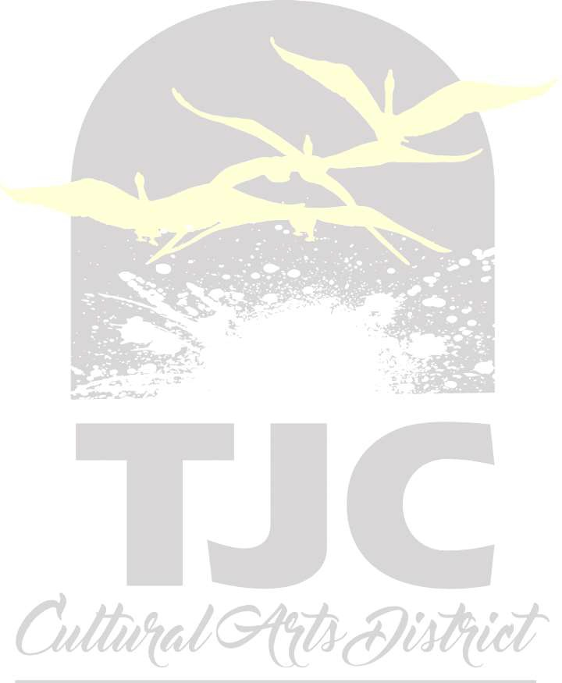  MON | TUES |  | WEDS | THURS | FRI | SAT
 | Art Club Silent  1  Auction|  Jenkins Hall| Glass Case Gallery  “you are magic” interactive art event – 10am-2pm – Jenkins bell tower courtyard  Trombone studio recital – 7pm – RPPAC Wise Auditorium | Art Club Silent  2 Auction|  Jenkins Hall| Glass Case Gallery  Guest Artist Masterclass – julianne casey, voice – 3pm - RPPAC  Recital Hall  Guest artist recital – julianne casey,, voice – 7:30pm – RPPAC Wise Auditorium |  | Art Club Silent  3 Auction|  Jenkins Hall| Glass Case Gallery | Art Club Silent  4 Auction|  Jenkins Hall| Glass Case Gallery Closes at 2:00PM  Powerful Voices Speaker Series: Hakeem Oluseyi – 7pm - cesse  Woodwind studio recital – 7pm – Ornelas center bandhall | 5 euphonium & tuba studio RECITAL- NOON ORNELAS CENTER BAND HALL  _______________________  Play-reading series  3 pm Jean browne theatre | ETSO: Totality of  6  the Sun Concert  | 4 & 7:30PM | Wise Auditorium  __________________________  Play reading series  7PM Jean Browne Theatre
7 | 8 solar eclipse & spring fling – 11am-3pm – intramural field | 9 | Historical fencing demo – 3pm – apache rooms | 10 Wordcraft: read your work! – 3-4pm – J1109 | 11 Sherlock jr (buster Keaton film-1924) – 4pm – J1109 | 12 lunch on the lawn event-block party – 11am-2pm – outside – (Ornelas center bandhall in case of inclement weather) | 13
14 | 15 string & boren voice studio recital – 6pm – RPPAC Recital hall | 16 international day – 9am-2pm – apache rooms  Honors music recital – 7pm – Ornelas center bandhall |  | 17 mass comm guest speaker jerry morales – 12 pm – Vaughn library quest classroom  __________________  art guest artist & workshop – Joshua goode – 12-3pm – j188 & other locations | 18 art guest artist & workshop – Joshua goode – 12-3pm – j188 & other locations  __________________  Bell tower launch party – 2-4pm – tyler museum of art  ___________________  History guest lecture Dr. Brian Rouleau. "Comic Book Panels and the 38th Parallel: The Korean War in American Popular Culture”- – 4pm – J1109 | Trent voice studio  19 Recital | 11am |  Ornelas Center Band Hall  Percussion studio recital – noon – Ornelas center bandhall  ___________________  Dance: Peter Pan | 7PM | RPPAC-Wise Auditorium | Dance: Peter Pan |  20  2 & 7PM | RPPAC-Wise  Auditorium
Dance: Peter Pan  21  | 2 & 5 PM | RPPAC-Wise  Auditorium | Jazz Ensembles  22  Spring Concert | 7:30PM  | RPPAC-Wise Auditorium | 23 speech and debate team showcase – 5:30pm – RPPAC recital hall  ________________  Azerbaijani musical lecture/concert – 3pm – apache rooms 1&2 |  | Thunderdome Art  24  Competition | 12 –  3PM | Jenkins Bell Tower Courtyard  _____________________  Theatre Production: Summer and Smoke | 7:30PM | Jean browne theatre | 25 good lord bird, episode 1 (film-2020) – 4pm – J1109  ________________  Theatre  Production:  Summer and Smoke | 7:30PM | Jean browne theatre | French horn studio  26  Recital | Noon |  Ornelas Center Band Hall  _____________________  Theatre Production: Summer and Smoke | 7:30PM | Jean browne theatre | Concert Choir & Chamber  27  Singers masterworks Concert |  7:30PM | RPPAC-Wise Auditorium  Theatre Production: Summer and Smoke | 2:30 & 7:30PM | Jean browne theatre
Music  28  Spring music Graduation  Recital | 3PM | RPPAC-Wise Auditorium | Percussion  29  Ensembles  Spring Concert | 7:30Pm | RPPAC-Wise Auditorium | 30 journalism photography showcase and art sale – 11am-2pm – Jenkins bell tower courtyard  Symphonic Band  Spring Concert |  7:30PM | rppac-Wise Auditorium  Musical Theatre Showcase | 7:30PM | Jean browne theatre
EXTENDED EVENTS:

• ART CLUB Food Drive| April 1st – 29th| Jenkins Hall Art Department Lobby
• Glass Case Gallery Exhibition | April 8th – May 2nd | Joshua Goode | Glass Case Gallery
• The artistic legacy of buck schiwetz – tyler museum of art
20th annual high school art exhibition – tyler museum of art
The Beauty of Art and Medicine VII exhibition | On View Through April | RNHS Bldg., Faulconer Floor

